Description :

====

Running the API from Jenkins

Execute Window Batch Command

==============================

cd C:\Test Leaf\Postman\WithVariables

newman run Week2Day1ClsRoom.postman_collection.json -g workspace.postman_globals.json -e QA.postman_environment.json -r htmlextra

Build Triggers info :

========================

54 11 * * *

Jenkins Details:

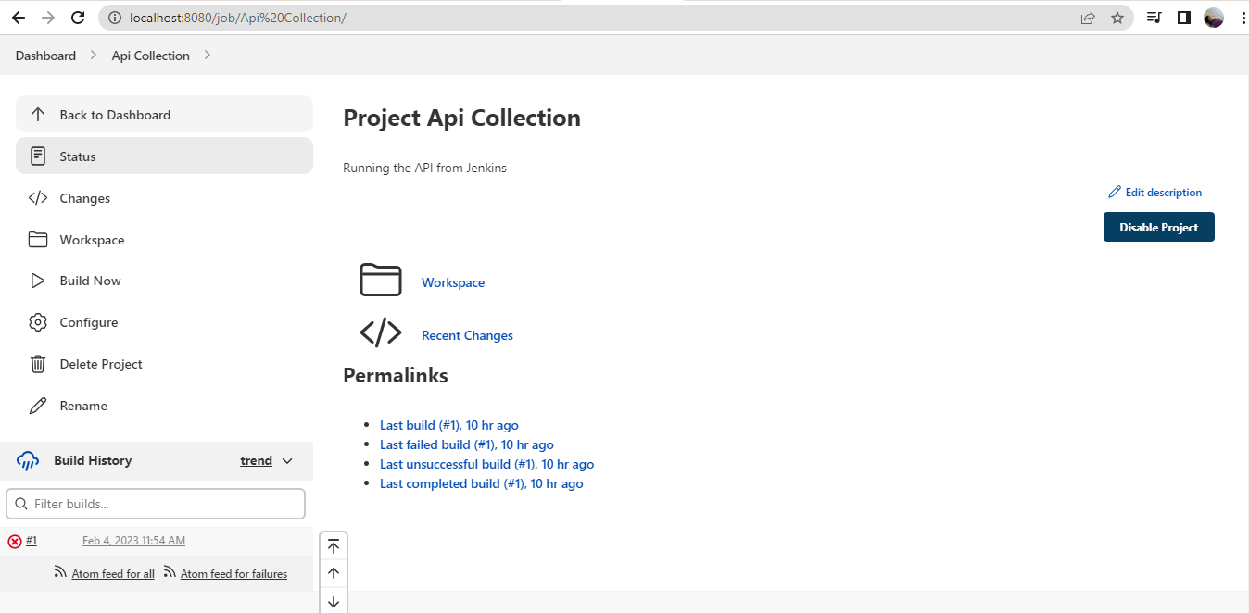

Report

